Resource Modeling for the Ahupua‘a of North Kohala Hawai‘i: How Cultural Borders Define Regional Ahupau‘a Self-Sufficiency
By Nicholas Ferriola

Background:
Subsistence resource production is the most essential part of human survival in any society, and higher population density means intensified forms of subsistence are increasingly necessary. In Hawai‘i this corresponded to two primary domains: agricultural and livestock production (land based), and marine resource exploitation (sea based). In most areas of the Hawaiian Islands, access to the sea and the various resources from mauka to makai (mountain to sea) was enshrined in the traditional cultural territories known as ahupua‘a whose borders “ran like a wedge from sea to mountains”(Pukui & Handy:48). The ahupua‘a also traditionally included a watershed that ran through it making the entire area theoretically self-sufficient. Despite this ideal, various factors contributed to variation from this ideal with some ahupua‘a being highly abundant in some resources while either completely lacking in, or simply being deficient in others. In this study I examined how this ideal specifically applied to the windward side of North Kohala moku, and whether the area’s traditional communities would in fact have been self-sufficient given the historically known ahupua‘a borders.
In order to examine the resources, we first have to consider the region as whole. North Kohala can be separated into a leeward (western), dry side, and a windward (eastern), very wet and lush side. This climatic difference, coupled with the remnant geological substrates across the region results in different physical environments that in turn lend themselves to very different subsistence practices. This was especially notable in terms of how agriculture was developed and organized as not all ahupua‘a functioned entirely independently of their neighbors. A lack of abundant surface water resources on the leeward side affected the types of crops grown, the nature of agricultural production, and the potential for population expansion in ways that did not occur on the windward side. Geologically, the leeward side also had significantly less potential for erosion and incision in the rock which created so many streams on the windward side, meaning wetland agriculture was more prominent. Additionally, through investigation of borders the idea has been proposed how the ahupua‘a of Kohala were, over time, divided into smaller units (Ladefoged & Graves 2006:268). They theorized that the original units were based on major geographic features, and also proposed a possibility of a maximum effective community size, and decisive political factors as possible reasons for subdivision. Their studies on the leeward side of North Kohala, demonstrating a connection between ahupua‘a name similarities, the obvious bifurcation of particular territories from others, and combining factors proposing likely prior forms before later subdivision allowing for the process to be sequenced based on these concepts (Ladefoged & Graves 2006:268).
In this study I will develop and apply a similar approach to understanding the relationship between resources and community territories on the windward side of North Kohala. This research departs from the previous studies because I will be looking into how the resources themselves may have impact these subdivisions of larger to smaller territories, and how these subsequent subdivisions in turn affected access to critical resource. Because a subdivision of territories will necessarily correspond with a reduction in self-contained resources this in turn may have a negative impact on the ideal self-sufficiency of an ahupua‘a from a prior, larger, form. In this study, I will analyze coastal access, land area, and available freshwater sources. Surface water, due to its abundance, the result of higher rainfall, on the windward side will introduce an additional level of complexity because the number of streams and their extensive, but variable, watersheds means many territorial boundaries incorporate multiple drainages that may cross from one ahupua‘a to another. Because traditional Hawaiian water rights were strictly enforced, the amount and predictability of water available may vary by location and geography. This will potentially make for a complex situation in regards to inter-ahupua‘a relations. By modeling resource production this study will paint a picture of how well situated the various windward ahupua‘a were in relation to each other, as well as seeing how they might have needed to rely upon each other to make up for deficiencies. It is my expectation that while the bulk of ahupua‘a in windward North Kohala did maintain the traditional shape, reaching from mauka to makai, as the ahupua‘a subdivided further their self-sufficiency diminished leaving territories dependent on relations with neighboring ahupua‘a to survive.
Methods:
In order to understand what resources are present in the windward North Kohala the primary resource I have utilized are maps. These maps varied from historical registered maps from the Māhele period of Hawai‘i’s history up to modern day sources such as the State of Hawai‘i official GIS maps.. Having these broad geographical sources to study provided redundancy in some variables that allowed me to corroborate or fill in geographic features when they were at times absent on some maps but present on others. This was particularly of use when looking at water sources where visible and listed secondary drainages varied heavily from one source to another. This presents a significant complication as the historical sources were inconsistent regarding which drainages they considered significant enough to note, and modern USGS data as well as the state GIS data only show modern water sources. Because the region faced a century of heavy sugarcane farming and all of the land grading and water redirecting associated with cane farming, what secondary drainages were there may have been filled in or graded over meaning we may be lacking knowledge of potentially important watersheds. Additionally utilizing the historical maps I was able to reconstruct a more complete picture of the territorial borders for the ahupua‘a in windward North Kohala. This was a trial in building a model for the possible “okana ahupua‘a” that may have predated the currently known cultural borders.
Utilizing ArcGIS and Google Earth I was able to take accurate measurements for each of the proxy resources being examined: area, coastal access, and fresh water access. These measurements proved essential in understanding how the system functioned, as well as allowing solid modeling of what was available. This was all a lead-in to examining possibilities of each ahupua‘a may have originally been organized. Because each featured resource has an impact on the sustainable self-sufficiency of the ahupua‘a, a similar examination of measurements for these okana ahupua‘a and their impact was done. How each measurement was used is detailed below.
Land area:
Land area was essentially used as a proxy for arable land in a given ahupua‘a, that is to say I modeled under the presumption that having more land area would necessarily mean more agricultural production capacity. Because of the known cultivation of dry-land crops in addition to the wet lo‘i I could not presume that a lack of irrigation meant no agricultural activity was present. While the specific composition of the land would be significant in refining the model as irrigated farming was generally more productive, because it is known that the Hawaiian people farmed even on less than ideal lands, presuming land to be fallow simply due to non-ideal composition was not reasonable. As a result of not negating any of the ahupua‘a territory categorically, the land area measurement additionally served as the dependent variable in all statistical calculations used. While the coastal area and stream length measure were weighted based on various facets the land area was taken and used as is. Finally, when examining the theorized okana ahupua‘a actual examination of ahupua‘a land area leads to a better understanding of how a process of gradual territorial subdividing impacted those territories.
Coastal Access:
The coastline of each ahupua‘a is the first independent variable used in this study, and in this case is weighted based on the available resources, not just on the actual length. In that sense it is less about the direct measurement of coast available and is being used as a proxy for the amount of sea resources available. To determine the realistic utility of a given ahupua‘a’s coastline I used cliffs as a negative factor, penalizing the measurement by a factor of .5 as access to resources would be restricted. In contrast, because bays provide conveniently abundant resources as well as an ideal launching point for fishing vessels, I used the presence of embayments as a positive, factoring a 1.5 multiplier, while those that had bays in addition to a cliff coastline received only a reduced 1.25 bonus multiplier. This, much like the land are leaves us with a high variance in measures across the region, and several ahupua‘a without a coastline at all. Nunulu-nui, Nunulu-iki, Puuokamau, and Maulili each are entirely landlocked, and all of those except Maulili “cap” other ahupua‘a being exclusively in Mauka regions. Otherwise the trend is sensibly that the larger ahupua‘a tend to have larger amounts of coast and vice versa, even more-so when considering the weighted measures.

Water Availability:
The final factor, and second independent variable examined is how the availability of fresh water factors in. Firstly, measuring the available stream-flow provides an approximation for how much of the landscape could have been irrigated. In particular examining a correlation between the land area to the available watershed streams provided possibilities based on how historically known proposed Okana ahupua‘a were set up sustainably. A minor complication for the region was that, unlike most of Hawai‘I where the cultural borders are usually formed by the ridgelines, many ahupua‘a borders in windward North Kohala are formed by the streams themselves. I performed two measurements for each ahupua‘a’s watersheds: one with the stream length split for areas where it formed a border under the presumption that the people shared the water with their neighbors and thus the length halved, and the second where the stream length was applied fully to both ahupua‘a. Due to the high rainfall on the windward side and the resultant high viability of dry-land cultivation, streams and other drainages alone do not determine the extent of the agricultural landscape. Yet still the prevalence of irrigation in the region certainly enhanced production, and additional evidence found on the ground demonstrated that water resources were being shared across borderlines. What this means for inter-ahupua‘a relations in regards to resource availability will be discussed further as well.

Data Analysis and Discussion
In this section I will examine the relationships between the coastline length and stream length on the size of each territory. Additionally these relations will be examined in relation to how they will impact the self-sufficiency of each ahupua‘a. There will also be analysis of a possible resource threshold at which a given ahupua‘a would be considered deficient in a given resource. As mentioned, the data used is primarily derived from three measurements, and each are looked at in depth.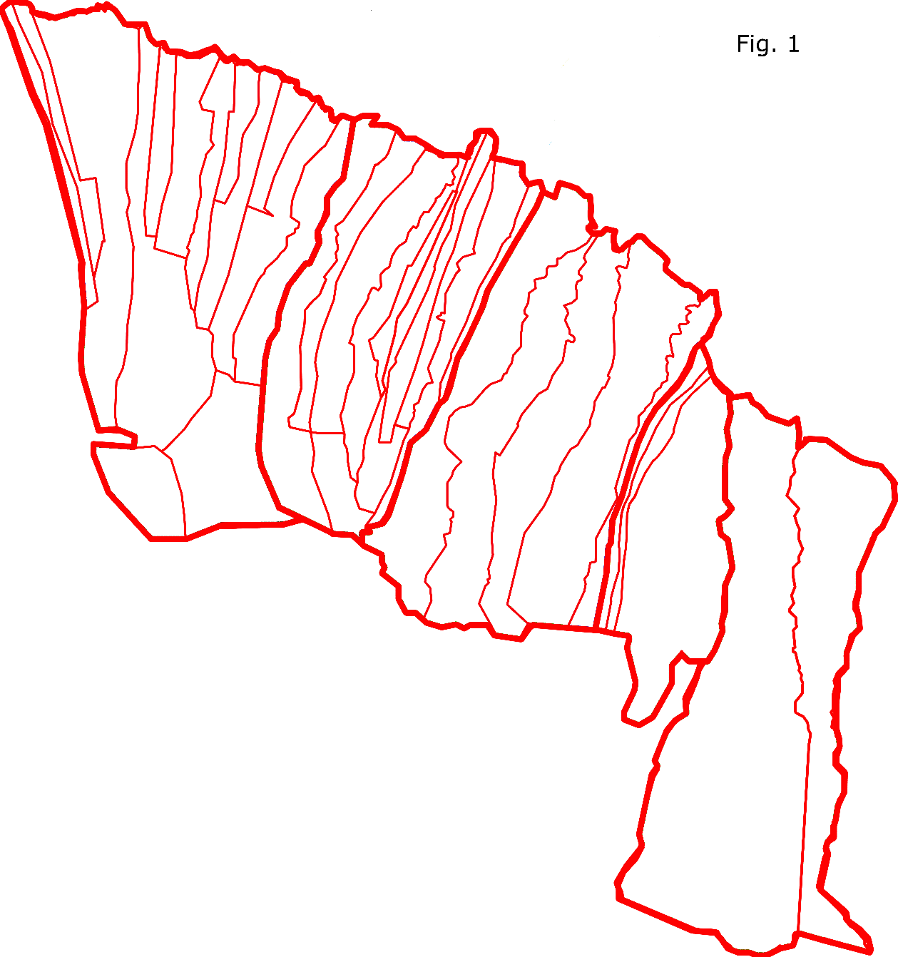
Firstly we have the overall land area. These data were generated through GIS software. Territorial area across this highly diverse region, suggest generally larger ahupua‘a in the east, a focused cluster of smaller ahupua‘a towards the central region, and a more variable mix of small and large as one reaches the farthest west. In this there are of course exceptions, such as Makanikahio 1 and 2 which are located in the east but are among the smallest ahupua‘a, measuring only 48.9 and 93 has respectively. Kapa‘au is another, that breaks the trend as it is central, but notably large (488.4 ha) compared to its neighbors which are generally in the 100-300 ha range. Similarly Kāhei (636.8 ha) and Ka'auhuhu (652.4 ha), which are both near the farthest east, are much larger than other nearby ahupua‘a. In examining the overall land area it should also be noted that the easternmost region contains the largest ahupua‘a analyzed, Honokāne, which at 1902.9 has is more than double the next largest ahupua‘a, Āwini, which also happens to share its western border with Honokāne.
The second set of data represents a weighted measure for each ahupua‘a’s coastline. Weighting the length of coastline associated with each ahupua‘a provides a much better picture of utility (and access to marine resources) than simply using the overall coastline measurements. The windward region of North Kohala is largely cliff line with a few major bays, most significantly at Kapanaia Landing, Keokea Harbor, Neue Bay and the mouth of Pololū Valley lending these areas a significant advantage. With this weighting the ahupua‘a with the highest coastal measurement again diminish as one moves to the west with the largest ahupua‘a generally having better quality coastal access. There are, again, exceptions although very different from the exceptions in area. In this case, the first exception includes four ahupua‘a, which are completely landlocked: Maulili, Pu‘uokamau, Nunulu-Iki, and Nunulu-nui. Because of their landlocked status they obviously have no coastline and thus a disproportionately low comparative ratio to size. Significantly though, there are also several ahupua‘a with a disproportionately high coastline (relative to overall area), such as Wai'āpuka which has a 1530 m coastline, while being on only 214 ha of land. For Wai'āpuka this is a result of its access to Neue Bay, and a winding coastline. Just the opposite situation occurs with ‘A‘amakāō, which having 706.1 ha of land area has a very limited, 451 meter weighted coastline despite the coastline being the entire southern area of Kapanaia Landing. In all though, there is a trend towards the ahupua‘a with greater land area to have more coastline.
The third variable is the amount of stream water each to which each ahupua‘a had access, as measured by the total length of drainages, both primary and secondary. These measurements were obtained through measuring streams in the current State of Hawai‘i hydrology GIS data, and also through the measurement of other drainages from the historical Land Commission Award (LCA) maps.This particular variable displayed a number of extremes. There were many ahupua‘a, such as ‘A‘amakāō with very high (20.098 km) stream measurements, and others such as Maulili that had none, or others such as La‘aumama with nearly no visible stream drainages contained within its boundaries. While it would be natural to expect the largest ahupua‘a to have the most access, this is not always the case, particularly as you go farther west. While the extremely large Honokāne and Āwini do have excellent stream access (26.811 km and 16.022 km respectively), other large ahupua‘a such as Kāhei are notably deficient at a mere 553.5 m, while at the same time, some smaller ahupua‘a such as Nunulu-nui (5.623 km)and Napapa‘a (3.539 km) have stream access disproportionately greater than their larger neighboring ahupua‘a. The most stark of these comparisons is with Kapu‘a which boasts only 90.6 has and yet has 3.026km of stream. The most notable trend in water availability, however, is the tendency towards higher water availability being in the East. Because of the extreme dryness of the leeward (west) side of North Kohala, it is unsurprising that as one gets farther west the drier it becomes.

Quantitative Analysis

Next I analyzed each of the bivariate measures for the three variables using simple x-y scatters, where the land area is the dependent variable, and weighted coastal length and stream length are the independent variables. Using these bivariate scatter, following developed the best fit linear equation and calculated a Pearson’s correlation coefficient. While all of the measurements showed positive, significant correlations the strongest correlation occurs between land area and stream length for all ahupua‘a. The correlation was an R=0.8448 which proved very high (R²=0.7137). As can be seen in the scatter there is a high degree of clustering in lower-left quadrant which of course includes the bulk of the central area ahupua‘a as well as the smaller ahupua‘a such as both Makanikahio 1 and 2 and La‘aumama. Other than that highly clustered segment, there is a relatively wide spread of ahupua‘a making up the rest of the scatter, mostly demonstrating the linear correlation noted. This also suggests that the territorial size of these communities is related to the stream length which is in part influenced by the borders often being formed by the local drainages. A common trend seen throughough the region is that the smallest ahupua‘a such as Maulili Pueke tend to have very little in the way of streams.
The correlation of land area to weighted coastal length was also positive and significant with a Pearson’s R=0.7343, (Figure 3). While the strength of the correlation is not as strong as the previous case, more than 50% of the variance of land area (R²=0.5393 is accounted by the weighted coastal variable.

The final comparison involved the two independent variables: the weighed coastal measure, and total stream length. The correlation coefficient of R=0.5962 is significant but lower than either of the previous analyses.
These analyses support the conclusion that at the scale of individual ahupua‘a there is a relationship between ahupua‘a size or area and these proxy measues for available subsistence resources, with the strongest relationship being between stream length to total area.
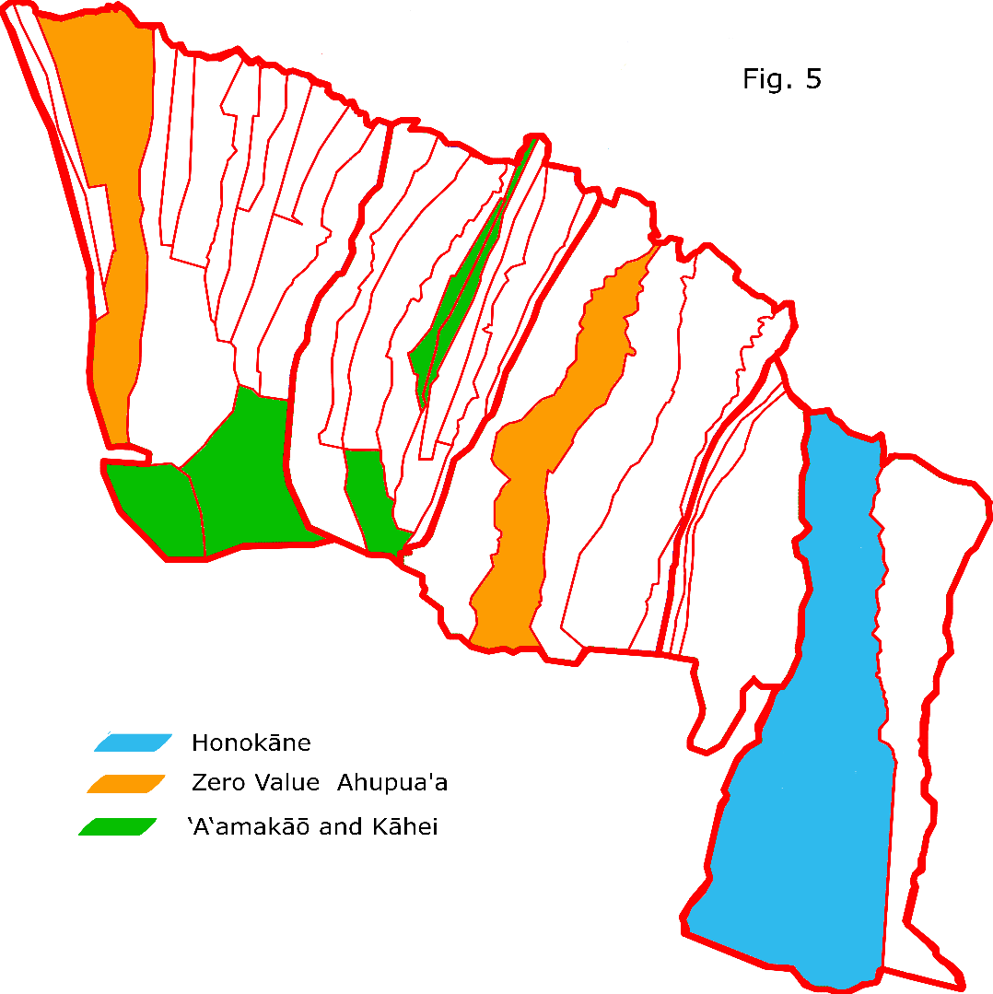
Impact of Outliers
After examining the original correlations it appeared that certain ahupua‘a were potentially skewing the results. Most noticeably Honokāne, being by far the largest of the ahupua‘a was an outlier whenever the ahupua‘a land area was factored in. Yet, removing Honokāne from the correlations did not increase their value. Rather its elimination had a negative impact. In terms of impact it seems
 | Fig. 6
Measurement Comparison | R Value With Honokāne | R value without  Honokāne
Land:Stream | R=0.8448 | R=0.7753
Land:Coast | R=0.7343 | R=0.7039
Stream:Coast | R=0.5962 | R=0.4810
reasonable based on this result, that despite Honokāne’s high size in comparison with the other local ahupua ‘a does fit with the model in terms of how its resources related to its size.
 | Fig. 7
Measurement Comparison | R Value With 0 Values | R Value w/out 0 Values
Land:Stream | R=0.8448 | R=0.8452
Land:Coast | R=0.7343 | R=0.7304
Stream:Coast | R=0.5962 | R=0.5634
At this point I chose to see what impact outliers which were entirely lacking in one or more resource were having. This included the landlocked (Maulili, Nunulu-nui, nunulu-iki, and Puuokamau), as well as removing those which had no known access to stream. By the same token there were several ahupua‘a (Maulili, Puuokamau, and Pueke) which had no known access to streams. Though there may have been secondary drainages in these ahupua‘a, lacking the information to show that it stands to reason that if they were present they were small, and coupling that with the fact that two of the three ahupua‘a lacking streams were also ones lacking coast, all five of these ahupua‘a were removed from consideration while reapplying Honokāne to improve the predictability of the model. The result of this evaluation was very minor, and inconsistent making the land area to stream length correlation a tiny bit higher at R=0.8452, whereas with the land area to weighted coastline and the weighted coastline to stream length, the R dropped very slightly.
At this point it seemed that there could potentially be other ahupua‘a unduly influencing the correlations. When analyzing the data represented in fig. 4 it was noted that there were two extreme outliers in relation to the independent variables, one with an extremely high stream area and very little
 | Fig. 8
Measurement Comparison | R Value With All Outliers | R Value with no Outliers
Land:Stream | R=0.8448 | R=0.9033
Land:Coast | R=0.7343 | R=0.8024
Stream:Coast | R=0.5962 | R=0.8552
coastline (‘A‘amakāō) and another featuring the opposite traits (Kāhei). Because these two seemed unique in their extremes in respect to the rest of the region, and because based on further analysis, it seems ‘A‘amakāō and Kāhei could possibly represent two very different and extreme ahupua‘a organizational ideals, those two were iteratively removed in addition to the logically impossible. This change in data resulted in a much higher (and positive) impact on correlation, with all measured comparisons improving. With this result it is clear that the bulk of ahupua‘a in the region do match the model: resources increase at a relative proportion to each other, and territory size. By this token it seems in the local territorial organization there was at least some effort to keep a things proportional, even if they were not equal.

As a significantly high correlation has been established the next step in analysis was to check the significance of the correlation to ensure that they were not likely to be happening simply by chance. To this end I ran a multi-variable regression on all three variables, as well as regression on the independent variables together, both with all ahupua‘a included, as well as with the previously mentioned outliers removed to ensure see if the significance would be higher with a better r² correlation. In this series of regressions I used a threshold of 99% to determine whether or not the null hypothesis should be discarded.
When the original measurements were checked in regression, an already reasonable significance was found. The multiple regression, using an R=0.8922 correlation, with a significance value of P<0.001, meaning it negates the null hypothesis. Similarly, all of the paired measurements similarly yielded high significance, all results for P negating random chance. Knowing that the likelihood of these results to be random is highly unlikely, it seems reasonable to assume that there was at least some effort in trying to maintain proportional resource distribution across the regional territories.
When looking into the results of the same statistical analyses without the outliers the correlations being higher, the results that come out remain positive: even with 7 ahupua‘a removed from consideration, all results have P<0.001 In all, it seems safe to infer that the relation between ahupua ‘a size and its naturally available resources has not occurred purely by coincidence, and even more notably the proportional distribution of coastal and stream resources.
Okana Ahupua‘a
In the next analysis I performed a reorganization of the data, in this case taking the various ahupua‘a and combining them into Okana ahupua‘a. This is best defined as several contiguous ahupua‘a which are speculatively connected at some point in the past. In this experiment windward North Kohala was divided into five Okana ahupua‘a which I designated Okana Honokāne, Okana Pololū, Okana Hālawa, Okana Kapa'au, and Okana Hāwī. These territories were designed based upon the shapes of the borders primarily, though rough size was also factored in when potential Okana ahupua‘a borders were unclear. The five Okana ahupua‘a I propose are setup thusly: Okana Honokāne is made up, numerically, of the least ahupua‘a being just Āwini and Honokāne. Okana Pololū is similarly made up of few ahupua‘a, those being Pololū, Makanikahio 1 and Makanikahio 2. Okana Hālawa is comprised of five modern ahupua‘a, those being Wai'āpuka, Niuli‘i, Makapala, ‘A‘amakāō, and Hālawa. Approaching the center of the region due to the increased clustering of ahupua‘a, Okana Kapa'au is made up of 11 others: Napapa'a, Halelua, Apuakohau, Kukuiwahulia, Pueke, Maulili, Hala'ula, 'Iole, 'Āinakea, Nunulu-nui, and Kapa'au. Lastly, Okana Hāwī is made up of more than any of the others, counting up to 14 ahupua‘a including Honopueo, Ohanaula, La‘aumama, Puehuehu, Kapu'a, Honomaka'u, Pāhoa, Hāwī, Ka'auhuhu, Kāhei, Hualua, Kealahewa, Nunulu-iki, and Puuokamau. The selection of this particular setup was based primarily on the historical ahupua‘a borders which often appear to have been cut out of a larger whole.
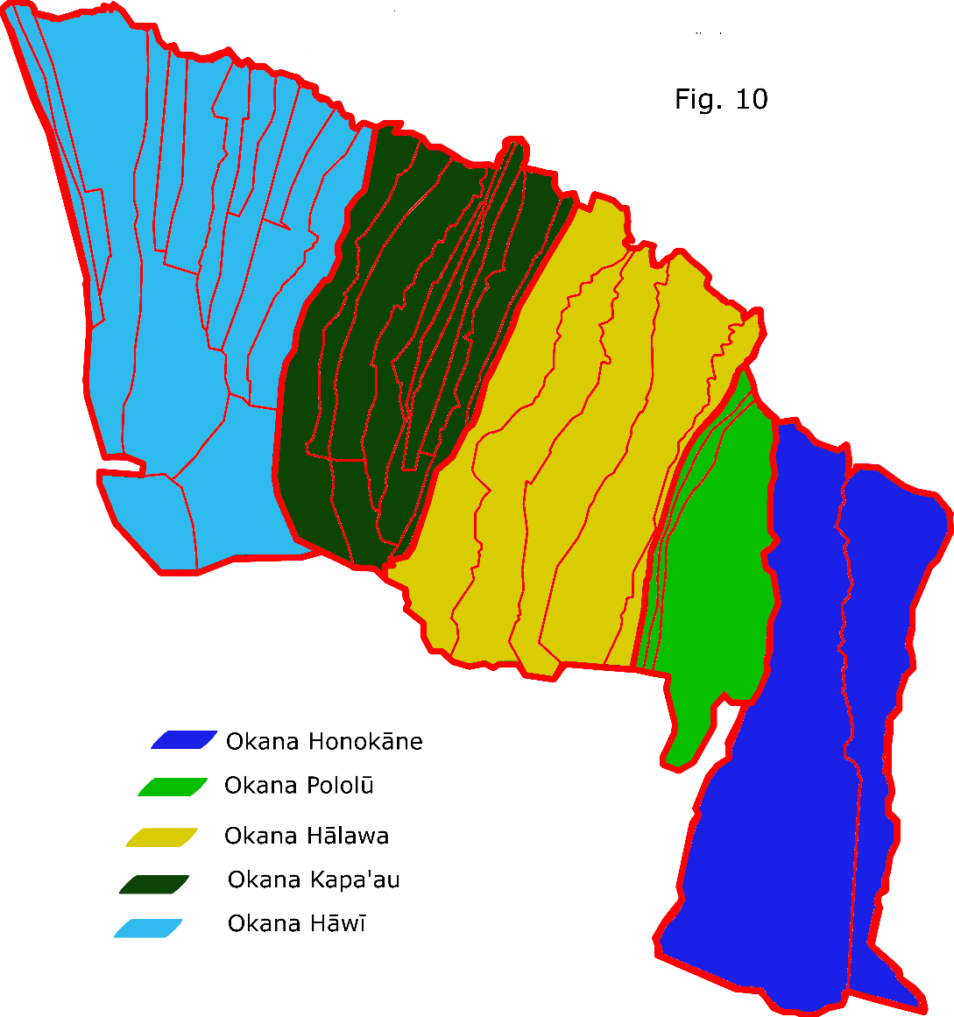
The most obvious repercussion of this consolidation of ahupua‘a is that each Okana ahupua‘a has an extremely significant portion of the region’s resources directly at its disposal whereas if using known historical and modern borders only Honokāne is large enough to be even considered to hold resources on that scale being more than double the size of the next largest ahupua‘a. Once they are in their Okana forms the rough sizes and resources become much closer to an even split. There are, of course, variances such as Okana Pololū being significantly smaller than the other combined units (only 914.6) it is also proportionally smaller in both its coastline and streams. By contrast the farther east, Okana Hāwī is in both size and coastal access the most well situated (3,767.68 ha and 10.073 km coast).

With these aggregated measurements I again created a series of x-y scatters examining the Pearson’s correlation coefficients. In this situation we again see relatively high correlations between the various measurements, even more so than the previous though the most significant is thus far the highest correlation which is between land area and coastal measures (R=0.9687). This extremely high coefficient means that it is a fairly safe assumption that a correlation on that degree implies that when these possible okana ahupua‘a were formed, there was intent to apportion land and coast in a proportional manner. The correlations on land area to stream length (R=0.6702) and stream length to coastline (R=0.8023) are also high, however slightly less so than the land area-coastline correlation. This overall high level of correlation lends credence to my proposed theoretical okana ahupua‘a borders. Additionally, because the known historical borders are uncharacteristically often found located on water sources such as streams and drainage gullies as opposed to the ridge-tops much more typical for Hawai‘i. This underscores the significance of the water rights as well as likely likely border stability in the windward North Kohala region. That even across these okana borders water sources likely needed to be shared across border underscores that when these borders were formed there was likely a high amount of cooperative activity in the region.
At this point, despite the sample size I ran regressions on the measurements for these proposed okana formations. In these analyses, due to the significantly lower N value, a significance of 95% was used instead of the prior 99%. I again started with the multi-variable regression to check the overall correlation, and found it was extremely high with R=0.9514. When analyzing the significance of that R value I found the significance to be less than it was when checking the individual ahupua‘a, but it still met the requirement P<.05. In examining the other measurement comparisons, the only other one to remain within the range to negate the null hypothesis was the measure comparing land area to coastline. Comparing the land area to stream length on the okana ahupua‘a received a value of P=.215, well above what was needed to negate the null hypothesis, while comparing both independent variables also resulted in P>.05. This serves to underscore that the sea was more significant to the earlier settlers than the inland areas were, as if they were a focus resource it seems more likely they would be statistically significant. This does not, however mean the streams and agriculture were insignificant, simply that the pressures for more intensified agriculture were not yet there.
Resources and Self Sufficiency:
Having established a model showing what the relationship between our three variables is, it is important to examine what this all means to the question of self-sufficiency. Again the individual measurements needed to be examined to show how the resources were spread across the various ahupua‘a. It should be mentioned that all okana ahupua‘a met the measure for self sufficiency in all categories.

First I looked at the land area. When analyzing the land area comparison between the 35 ahuapua‘a there is a general steady progression in size. There are exceptions as previously noted, particularly Honokāne with being more than twice the size of it’s the next largest ahupua‘a. Where we also see a divergence from this steady progression is at the 385 ha mark. As the only major breakpoint aside from Honokāne I applied a threshold of 400 hectares as a resource deficiency point for land area. While land area is not a direct measurement of available resources, it does, as seen in the prior analyses indicate a propensity for better access to both streams and coastal access.

A similar situation exists in the stream length measurements: A steady progression from the lowest to the highest measures with few major break points. In this instance I found a break between 2.334 km and 3.026 km. In this situation I chose to apply a point of 2500 m to set the deficiency point for the stream availability based on there seeming to have been some degree of effort to keep stream area above that level. While this may not have been a conscious concern, it may have simply been that the traditional ideal encouraged a certain degree of stream access for practicality.

With the weighted coastal length, there is again that familiar pattern of a gradual increase in coastline, except this time there are two major breakpoints. The first of these points is at 567 m of coast, whereas the second break was between the 1530 m and 2476 m. While the second break is a much more stark difference, the first break is much nearer the median for the coastal measurements, so a value of 600 was selected as the point threshold.
With this system of determining whether an ahuapua‘a is sufficient in a given resource most ahupua ‘a are deficient in at least one resource. This is particularly common in the case of the land area where only ten ahupua‘a are above the threshold of sufficiency. This is much less the case when looking at the sufficiency for the coastline and stream length. Additionally, the number of ahupua‘a that are insufficient in all three measures is nearly a third of those in the region (11). When looking at which are deficient in all measures, there is a high overlap between those that were previously defined as outliers due to having a zero value in one or more of the independent variables (excluding Nunulu-nui which does have sufficiency in streams . This accounts for four of these with the other seven which are insufficient in all measures being Hāwī, Puehuehu, La‘aumama, Kukuiwahulia, Hualua, and Makanikahio 1 and 2.
It seemed unlikely that over half of the ahupua‘a in the region would be insufficient, so another model was tried, this time using a combined measurement of all the factored resources as a proxy measure for overall self-sufficiency. In this analysis, an aggregation of the resource deficiency thresholds was used as the floor below which an ahupua‘a could be termed not self-sufficient (3500). When this was applied to each ahupua‘a a much more reasonable result occurs, where only twelve ahupua‘a would not reach the 3500 minimum for resource self-sufficiency.
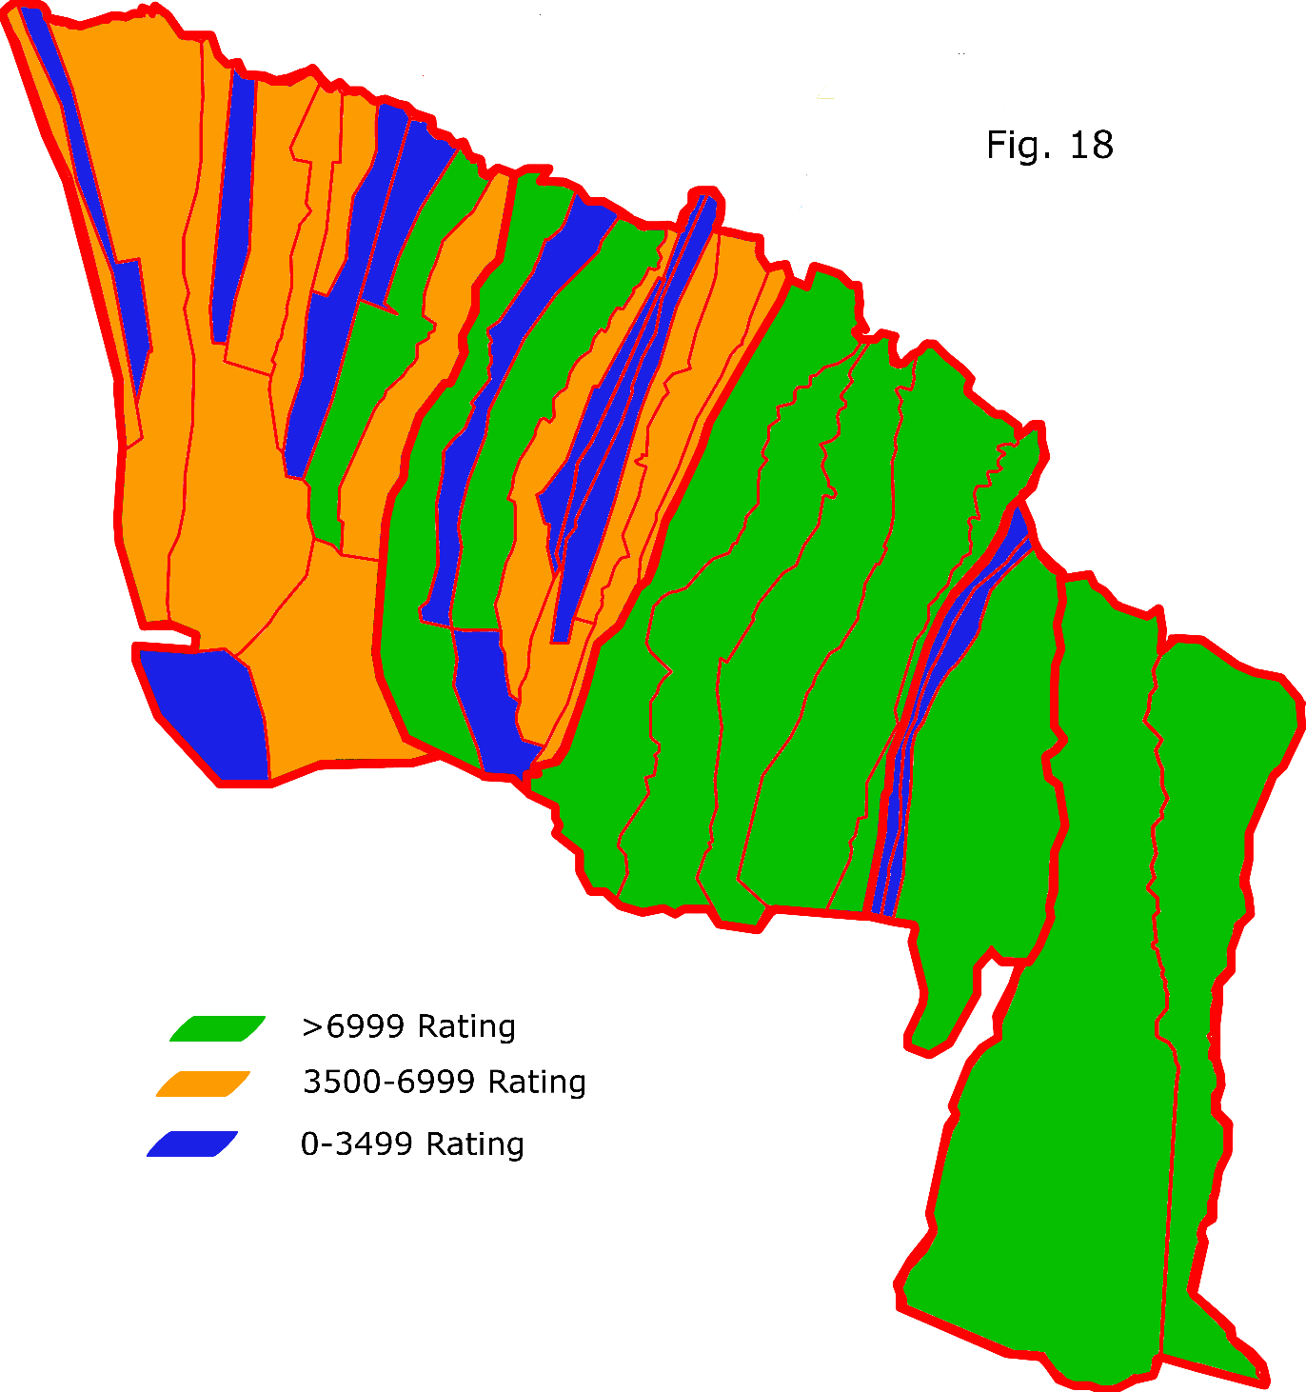
Even so, the ones that do not reach that threshold with only one exception always border at least one that do, and in half of these cases border ahupua‘a exceeding the self-sufficiency threshold by more than double. A prime example of this would be 'Āinakea, which while barely under the threshold for self-sufficiency has ’Iole bordering on the east and Kapa'au on the west, both of which far exceed that minimum requirement, meaning they were likely engaged in some form of resource exchange with those neighbors to supplement their lack. This could have been simply work crews, or it could have been an arrangement like in Makanikahio 1 and 2 where both ahupua‘a do not meet the self-sufficiency rating, and Pololū does. Here, we see at site MAA 12 that there was artificial drainages made that brought water from Makanikahio 1 and 2 into Pololū valley, likely for irrigation purposes. Because Makanikahio 1 and 2 are such small ahupua‘a and have so few water sources, diverting some water into a neighbor’s fields, could have been part of an arrangement with Pololū to compensate for their lack.
Also of note is that some ahupua‘a reach this self-sufficiency threshold without having significant access to one of the resources. Ahupua‘a such as Kāhei are extremely deficient in stream length, as a compensatory effect makes up for it both in size and in coastal access. This means that it is likely to have relied heavier on its coastal resources and utilized dry land agricultural practices which, while not as efficient, could be and were done. And as seen in Fig. xx there was a definite trend towards a lower degree of self-sufficiency in the west, which was particularly influenced by a reduction in streams as one travels further west.

Conclusion
When discussing any conclusions drawn here, I first must discuss certain weaknesses in this study which I hope to resolve. The first is the measurements themselves. While these were aided through technological means where possible through ArcGIS, there are certain limitations. Most notably is the fact that some ahupua‘a borders needed to be estimated based on the historical maps, which did not always perfectly line up with the State of Hawai‘i GIS maps’ ahupua‘a borders. This should be noted particularly in relation to Kāhei and the central ahupua‘a cluster around Maulili, and to the west of Hālawa. On a similar note, the stream lengths were based solely on State of Hawai‘I GIS data and the Lydgate historical regional map, and that has several problems. The first problem is that it may not include all present streams, though the major drainages are should still be represented. This weakness may be able to be rectified, but due to the aforementioned border estimations, where these extra streams will fall in regard to which ahupua‘a they belong to is less clear. Another issue is the land itself. Windward North Kohala’s landscape was heavily modified by the sugar cane plantations that operated there for a century. As a result evidence for what structures may have once been in place, and even more what they originally were, is difficult, meaning much of what has been analyzed is open to interpretation. That is not to say that the data and study were without merit. Even with some things estimated the general scaling of size will still be relatively accurate, and the coastal measures are as close to accurate as GIS measurements can make them. Finally, the data does not directly take into account what the impact of rainfall was on the region, which could be a much bigger impact on the western part of Windward North Kohala as the land becomes drier.
The data itself is in and of itself used to create a very simplified model of resource distribution, yet despite this there is as noted an extremely notable correlation between the measurements taken. Most notably was that when I examined the comparison of size to stream length of all 35 ahupua‘a together there seems to be a high tendency for the two to be highly correlated, and even more so when the outliers were removed for analysis. On the other end of the spectrum, when analyzing the size of okana ahupua‘a to coastal length we see a similar occurrence, and a lesser correlation towards stream length. But what does that mean as far as resource sufficiency?
Presuming that these okana ahupua‘a are in fact accurate, by extension it must also be assumed that these are older forms of land division than are seen in any historical map, and could potentially be centuries older forms of these ahupua‘a. By that token the okana ahupua‘a should be taken as forms that existed closest to the time of initial settlement of the island. In terms of subsistence strategies it makes sense that the earliest Polynesian settlers would have been focused most heavily on the coastal zones. Agricultural infrastructure was not in place yet, and there was likely a heavier reliance on fishing than would have been the case after populations grew and agriculture was expanded to be the more important subsistence producer. That is not to say that fishing stopped, as it clearly didn’t, but primary reliance on it likely dropped. From there it becomes easy to see why once agricultural infrastructure was in place the later divisions of these okana ahupua‘a into smaller units tended, with some exceptions such as Maulili and Pueke, tended to focus more on dividing up the streams so that each ahupua‘a had some irrigated agricultural production. The movement of water between ahupua‘a also presents an interesting potential compensatory strategy by which it is possible a lack was made up for.
In some ways this does confirm my original expectations, while in other ways it proves them a bit off the mark. Primarily there is certainly a cultural attachment to the ideal of how the ahupua‘a should be shaped and that form holds true to, at least some extent, for all but three ahupua‘a in windward North Kohala. Even the landlocked Maulili was clearly attempting to hold that traditional shape despite having no coastline or streams to fulfill its purpose of providing all resources for that territory. That said, using the model as shown, the vast majority of ahupua‘a did in fact meet that ideal resource self-sufficiency in the area, although not always in the expected ways. The aforementioned compensatory strategies, while they do take a step away from the traditional model, were still likely able to function independently, only having to rely on assistance from outside sources when it was desirable to do so.
Further analysis is certainly warranted though, and I am hoping the opportunity to continue will present itself. In particular it would be beneficial to go and examine the areas where the most well suited ahupua‘a border those labeled insufficient, such as where ‘Iole and 'Āinakea meet to see if there are any structures indicating connections that between those ahupua‘a. Also, it would be useful to see if any of the old ahu that were used to designate the territories are still standing, as if there was any potential to date their construction without damaging the structures, it they could prove to be a very valuable resource in formulating how and when the ahupua‘a were subdivided into the smaller units known today. While these would be ideal tests, since much of the area has been damaged by the sugar cane plantations that worked there for century, and so much of it is now private land, it may be difficult or impossible to find such detailed information, but even so, structures that went deep enough, may still have some remnant, as sugar did not grow extraordinarily deep.
Bibliography:
Gummerman, George J.
1968 The Role of Competition and Cooperation in the Evolution of Island Societies.

Ladefoged, Thegn N., and Michael W. Graves
2006 The Formation of Hawaiian Territories

Ladefoged, Thegn N., Charlotte T. Lee, and Michael W. Graves
2008 Modeling life expectancy and surplus production of dynamic territories in leeward Kohala, Hawai‘i. Journal of Anthropological Archaeology 27:93-110.

McCoy, Mark D., Gregory P. Asner, Michael W. Graves
2011 Airborne Lidar Survey of Irrigated Agricultural Landscapes: An application of the Slope Contrast
Method. Journal of Archaeological Science 38:2141-2154.

Pukui and Handy
Native Planters in Old Hawai’i, Their life, Lore, and Environment.

